**Govt Degree College Gummalakshmipuram Parvathipuram Manyam Dist** 

**Botanical Excursion Tour**

**Organised by Department Of Botany**

**Day and Date-Saturday 07th February 2025**

**Place : Botanical Garden Padmapuram – Araku Vally**

**: Horticulture Nursery - Kothavalasa**

: **Tribal Museum - Araku**

**Introduction:**

**Andhra University Visakhapatnam has introduced Study tour for B.Sc Botany Major I , II . Students. The department of Botany organizes study tour to create scientific temper among the students Excursions are arranged to give exposure to students. The students are required to submit tour report which carries certain marks in the University practical examination. So various study tour was arranged by department of Botany for B. Sc. Botany Major I, II student. Study tour has to organize to visit Padmapuram Garden and Horticulture Nursery. In the academic year 2024-25 we have organized one day tour at Botanical Garden Padmapuram – Araku Vally, Horticulture Nursery – Kothavalasa, Tribal Museum - Araku . For B.Sc. Major Botany I and II students.**

**Objectives: • An educational tour offers students of all Classes an opportunity for a rich immersion experience.**

**• An educational tour is great fun, it differs from a vacation, such trips provide invaluable global learning • Field education is equally important as classroom teaching.**

**• It adds vigour in learning processes and relieves monotones of indoor education.**

**• These tours help to build good repo amongst students and teachers.**

**• It will create interest in research attitude in student.**

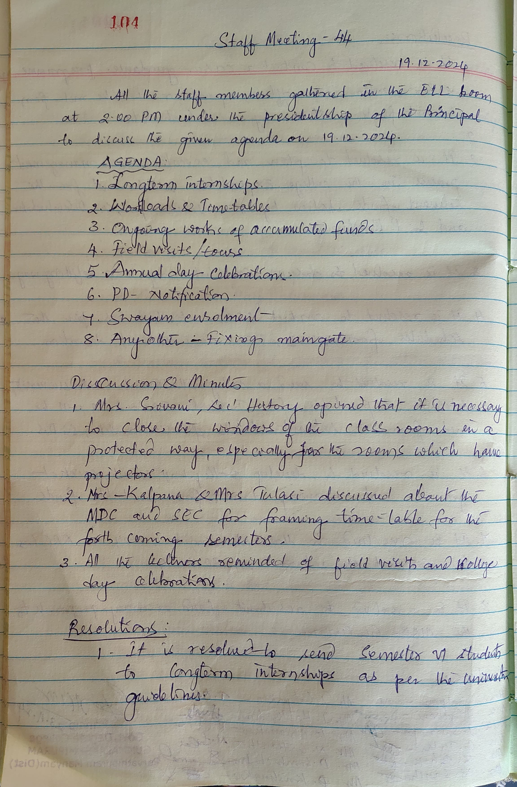

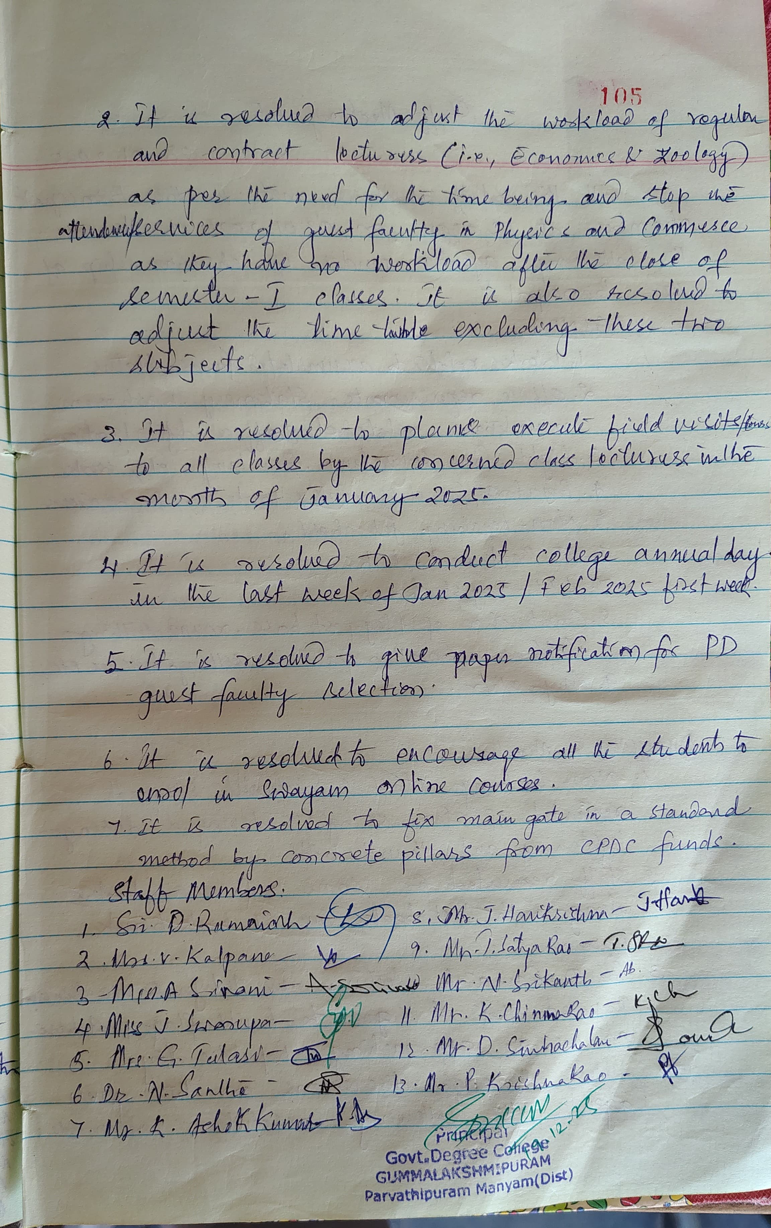

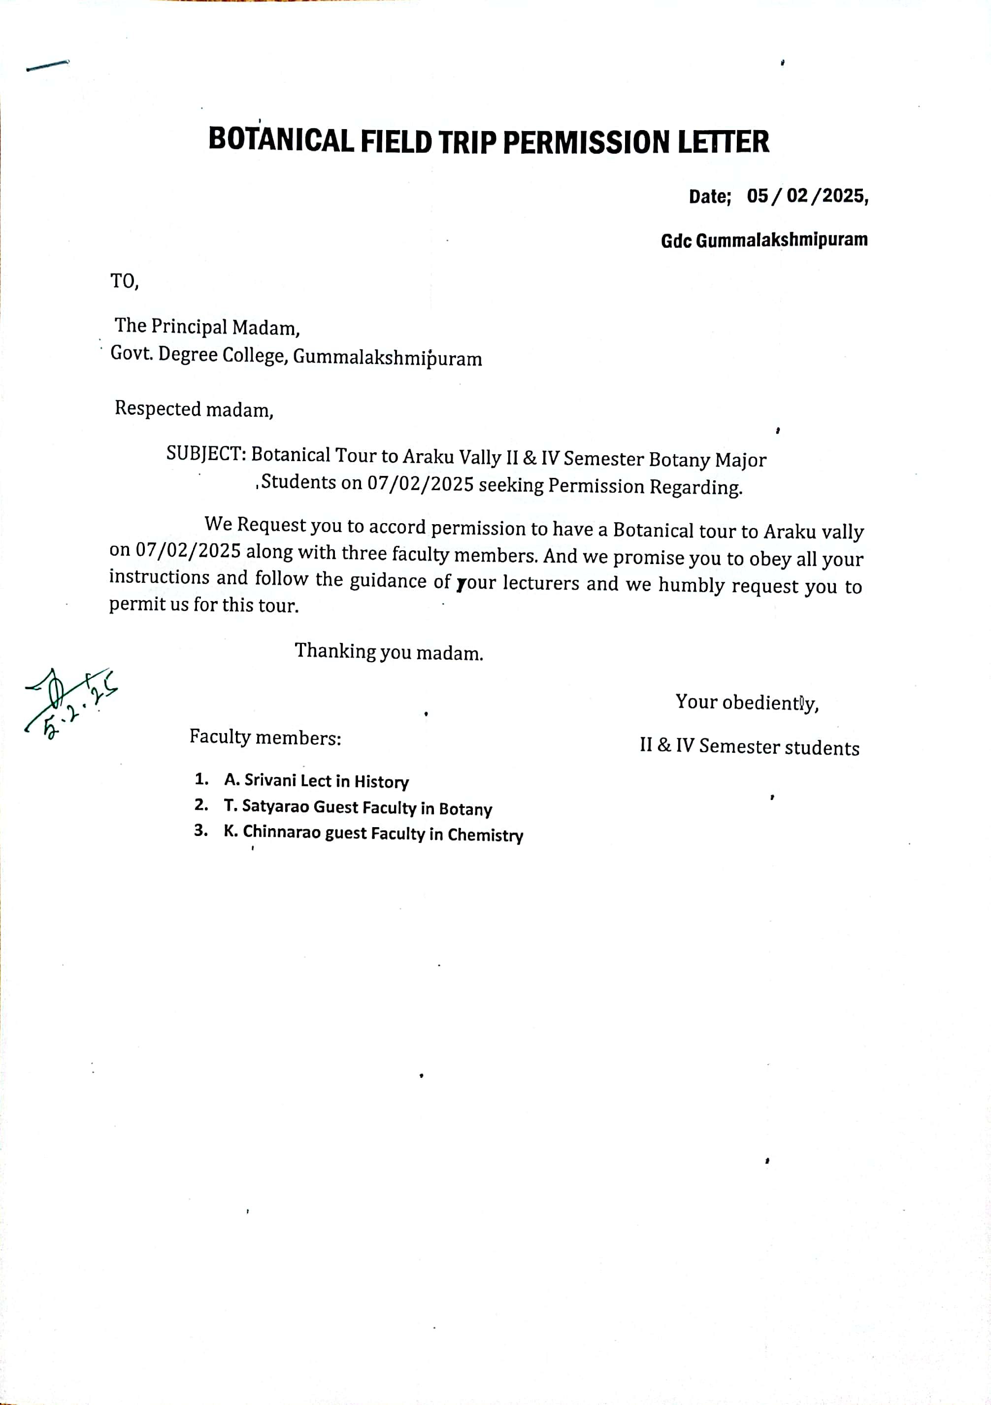

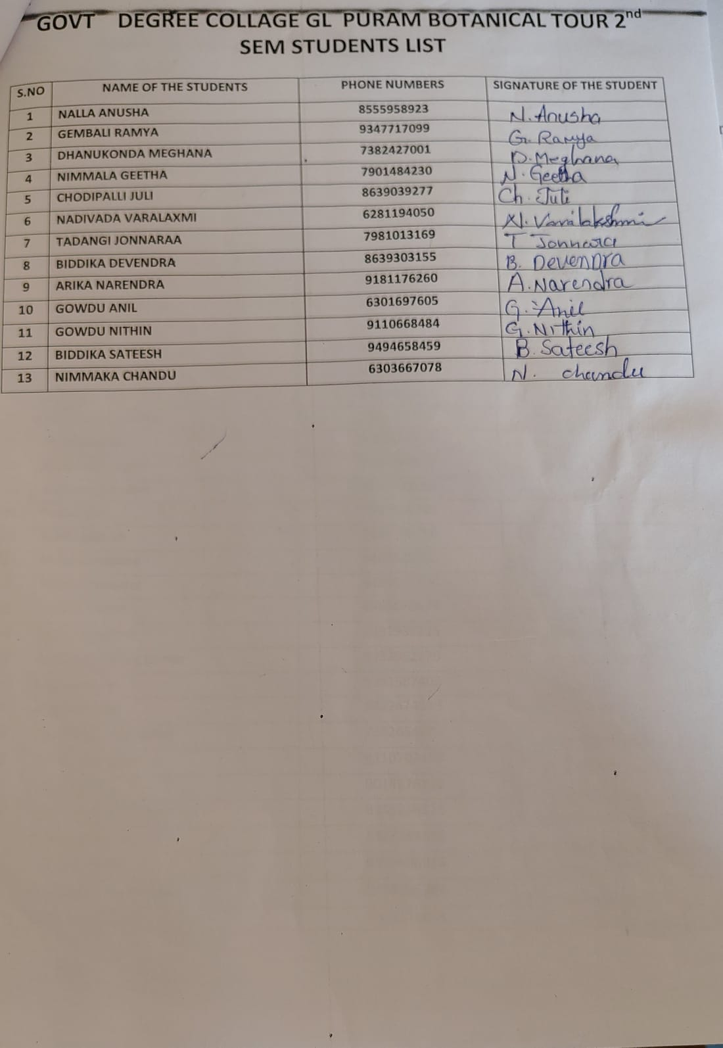

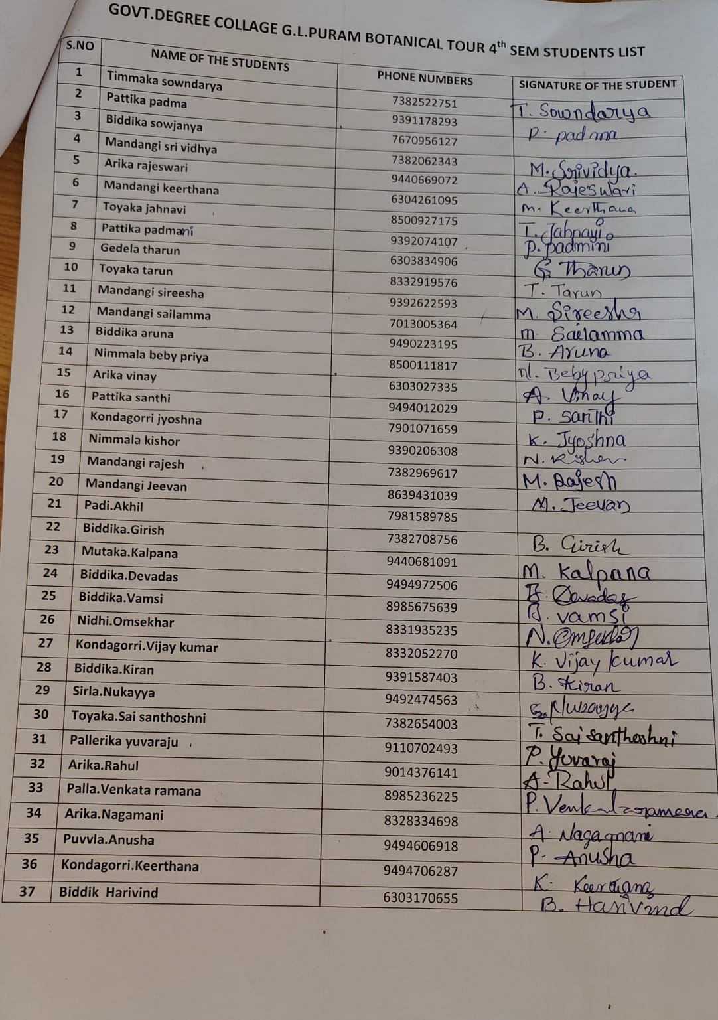

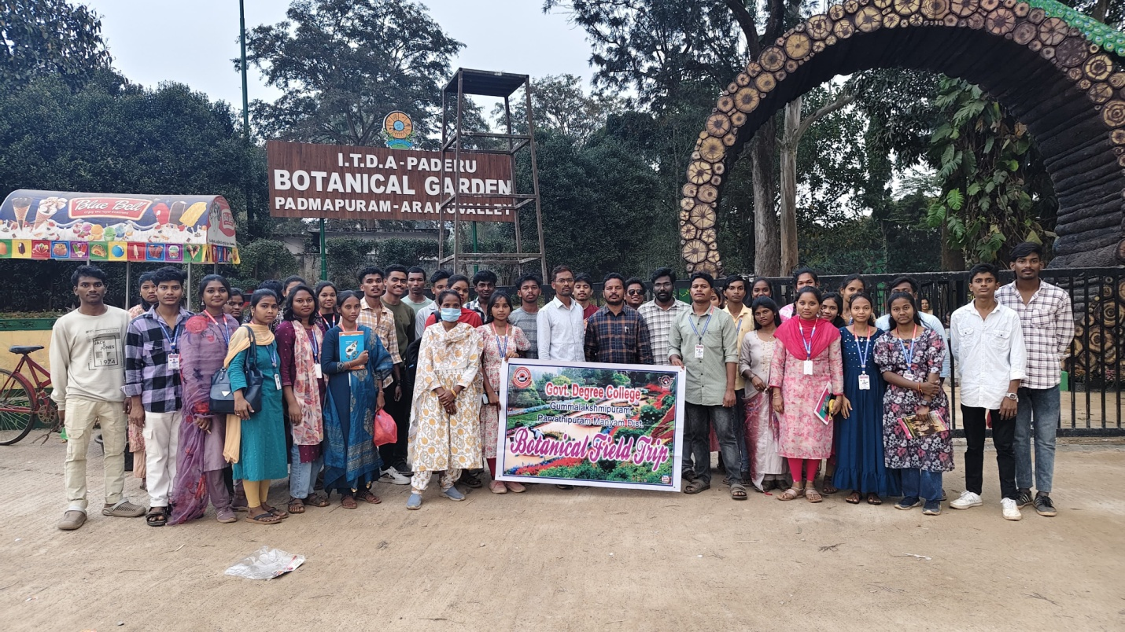

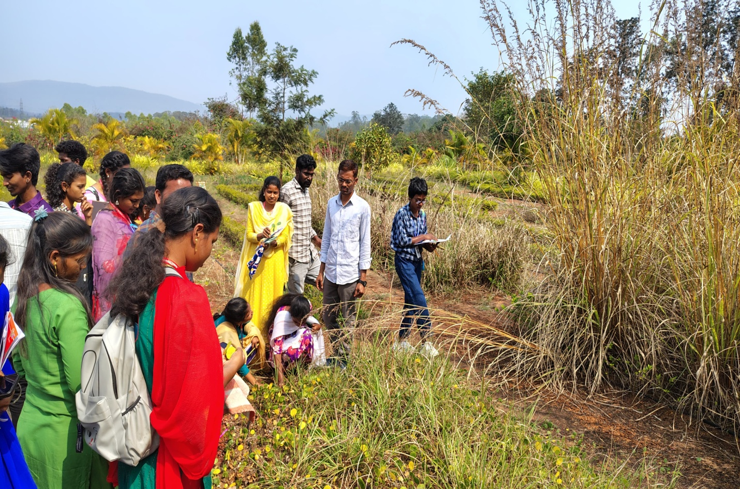

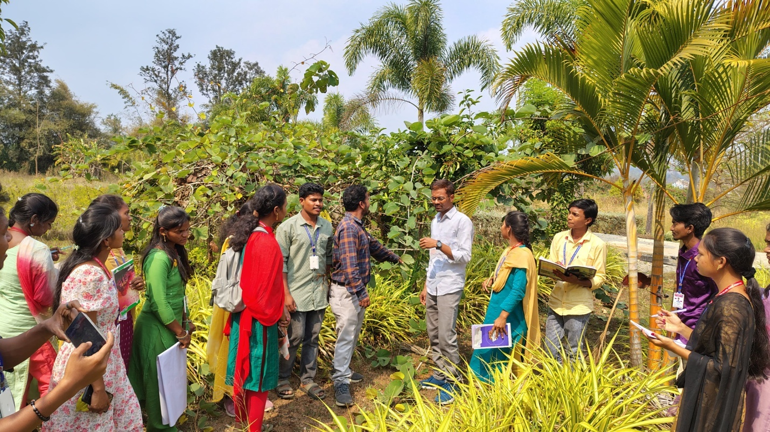

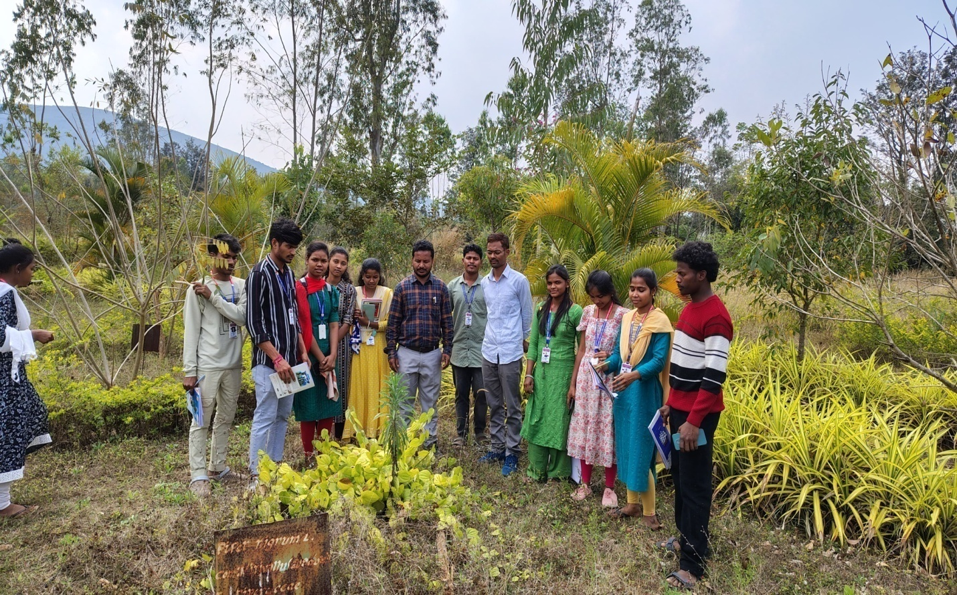

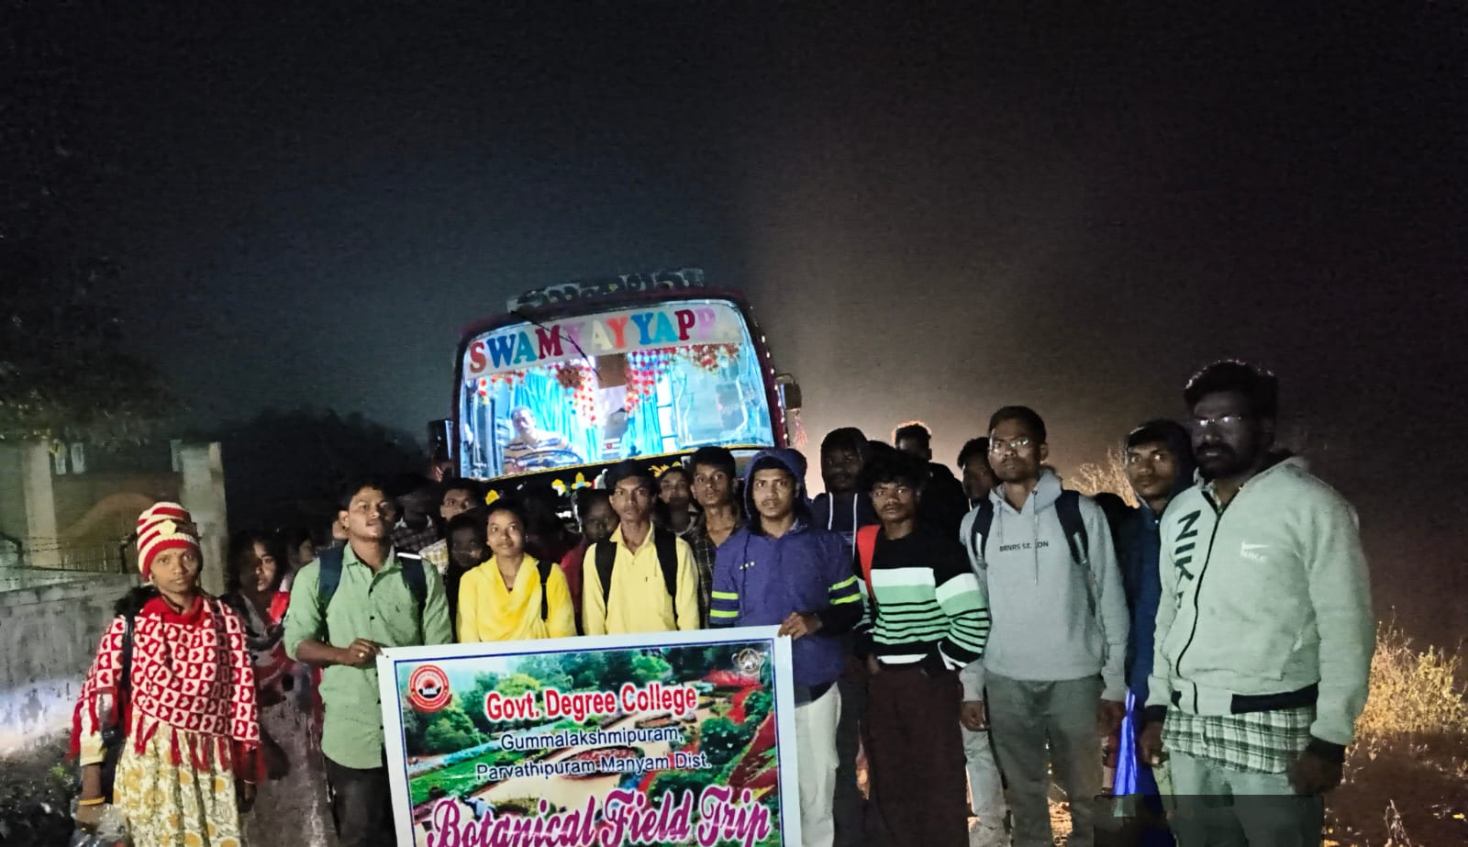

**Outcome: During the visit students observed the seasonal flora at visited places. Some lower plants like Cycas, Medicinal Plants and Bryophytes, Pteridophytes, Angiosperm and Indian Rare Plants which flourish during the rainy season have been observed and collected for the study.**

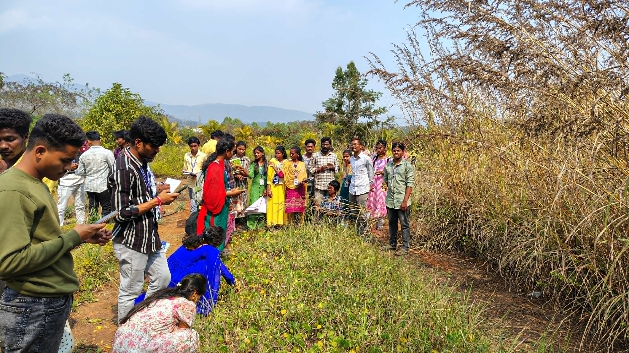

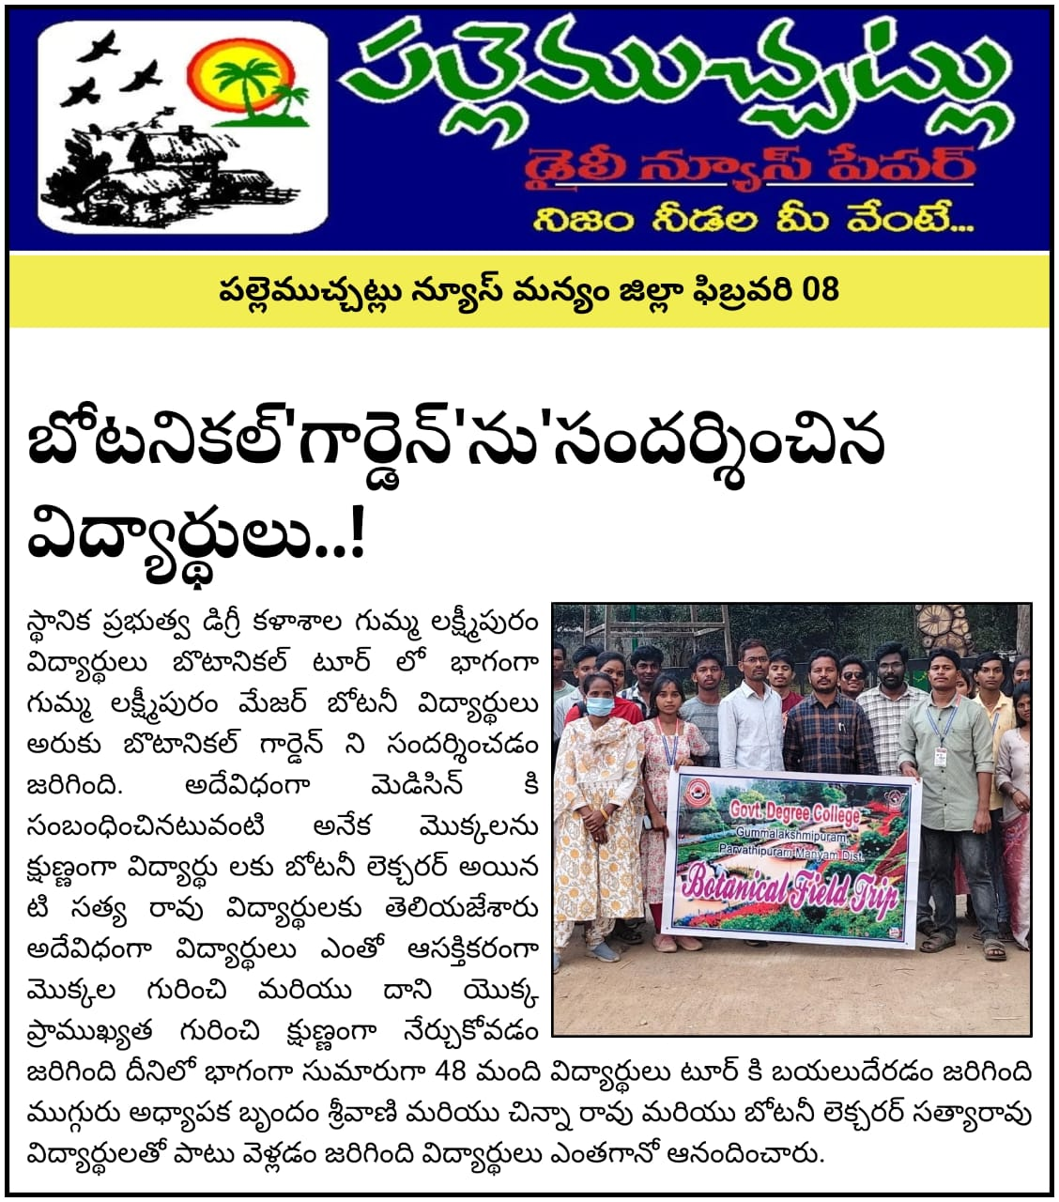

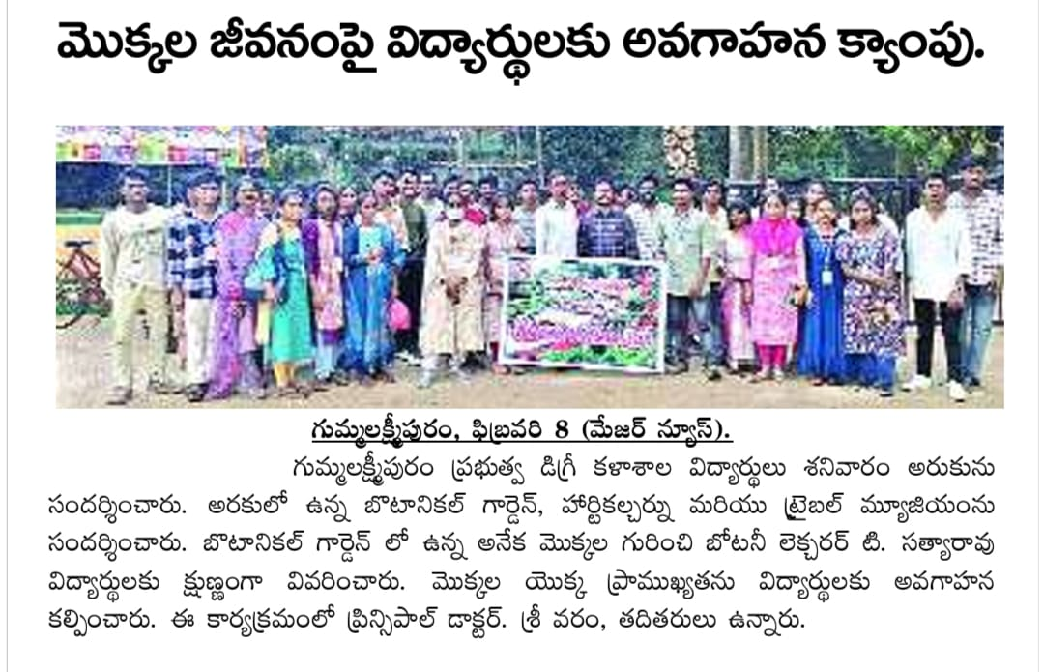

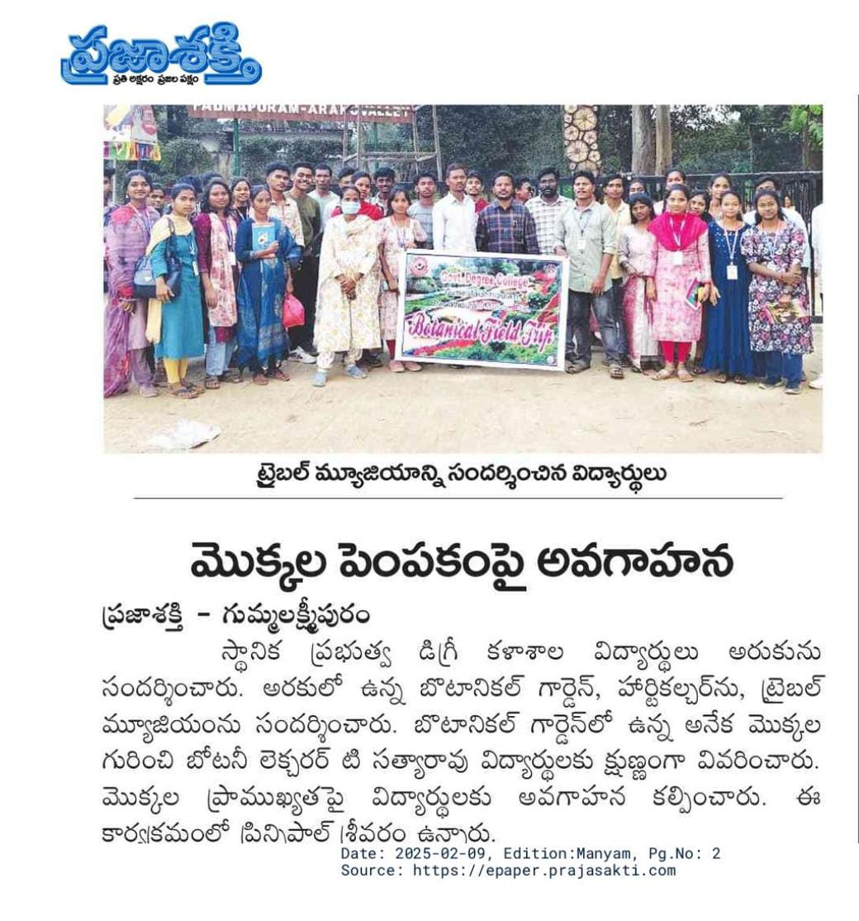

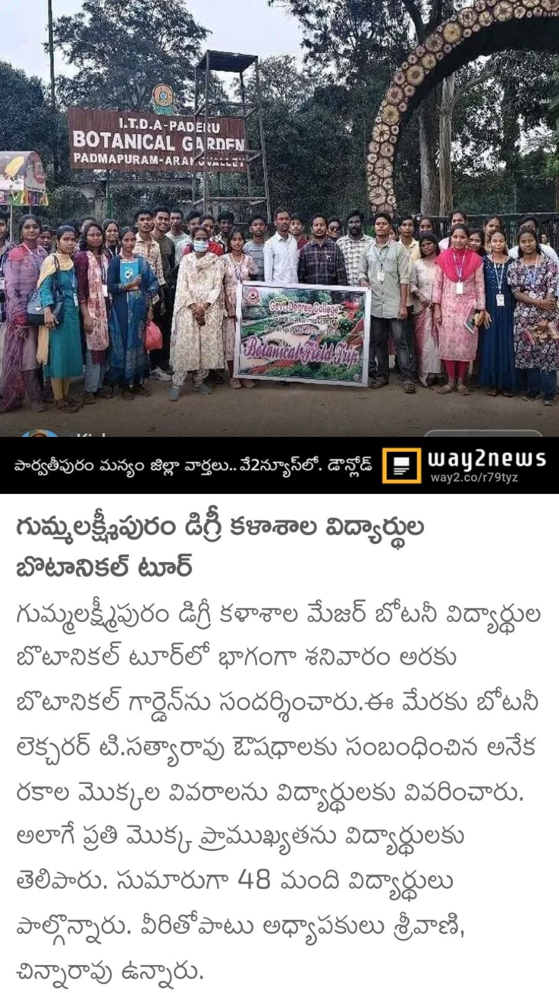

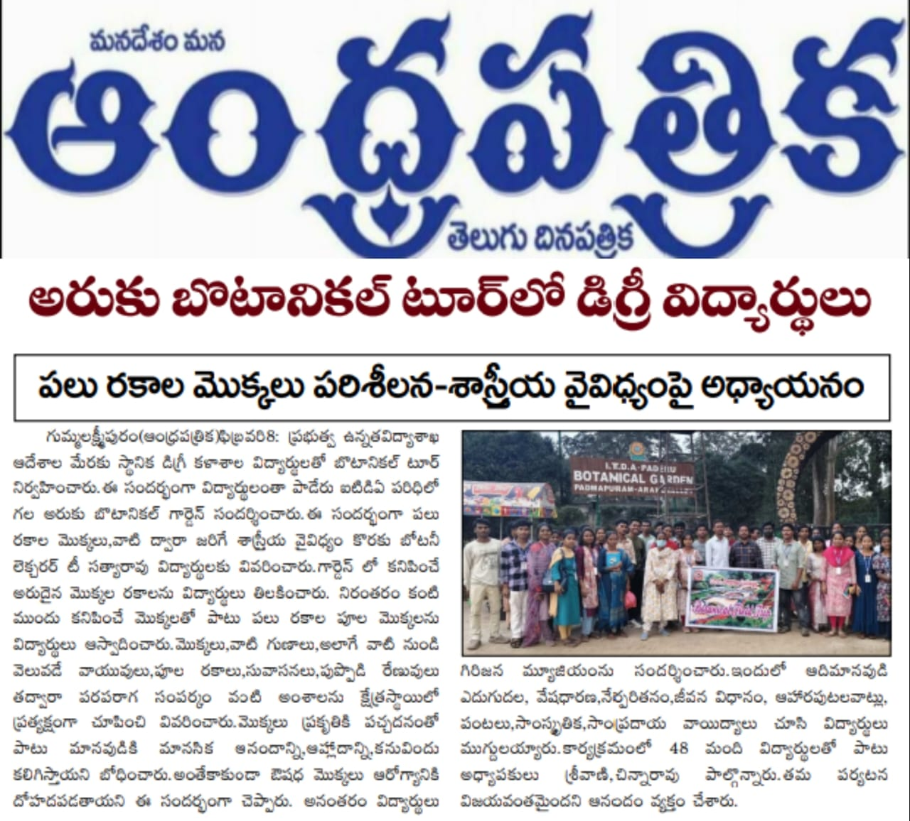

**Participants: B.Sc Botany Major I and II Students**

**Accompanying Teacher: 1. A. Srivani Lecturer in History**

**2. T. Satyarao Guest Faculty in Botany**

**3. K. Chinnarao Guest Faculty in Chemistry**

**CONCLUSION: Our study tour was very interesting, student participants interacted in a very well disciplined manner cooperated well with the teacher guides and overall the tour was grand success. We realised that viewing the flora and fauna in its natural form made us things vivid enhancing the classroom lectures and laboratory experiments.**

**Last but not the least I would like to mention the quotation 'PRACTICE WITHOUT THEORY IS BLIND AND THEORY WITHOUT PRACTICE IS STERILE" So theory and practice must go hand in hand all the time.**